1. To use the ribbon commands, what menu and grouping of commands will you

find the Insert and Delete command?

Home: This is the most popular bar and displayed by default when excel is opened. This tab contains the basic Clipboard commands, formatting commands, style commands, commands to insert and delete rows or columns, plus an assortment of worksheet editing commands.

2. If you set a row height or column width to 0 (zero), what happens to the row and

column?

**It sets to the default width or height.**

3. Is there a need to change the height and width in a cell? Why?

It is necessary to change width and height in excel **to fit the data**. Excel by default provide equal width and height with respect to columns and rows. Whenever we enter a lengthy data, few characters will get displayed and other will be present inside the cell but will be hidden to the user.

4. What is the keyboard shortcut to unhide rows?

If you want to unhide the rows, you can use the same keyboard shortcuts, but with the Shift key included. For example, to unhide rows that have been hidden with the first shortcut (Ctrl+9), you would press **Ctrl+Shift+9**.

5. How to hide rows containing blank cells?

To hide rows that contain any blank cells, proceed with these steps:

1. Select the range that contains empty cells you want to hide.
2. On the *Home* tab, in the *Editing* group, click *Find & Select* > *Go to Special*.
3. In the *Go to Special* dialog box, select the **Blanks** radio button, and click *OK*. This will select all empty cells in the range.
4. Press Ctrl + 9 to hide the corresponding rows.

This method works well when you want to hide all rows that contain **at least one blank cell**, as shown in the screenshot below:

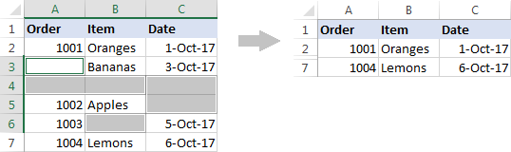

6. What are the steps to hide the duplicate values using conditional formatting in

excel?

In Excel, there are several ways to filter for unique values—or remove duplicate values:

* To filter for unique values, click **Data > Sort & Filter > Advanced**.  
  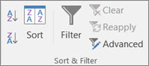
* To remove duplicate values, click **Data > Data Tools > Remove Duplicates**.  
  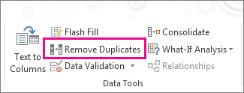
* To highlight unique or duplicate values, use the **Conditional Formatting** command in the **Style** group on the **Home** tab.